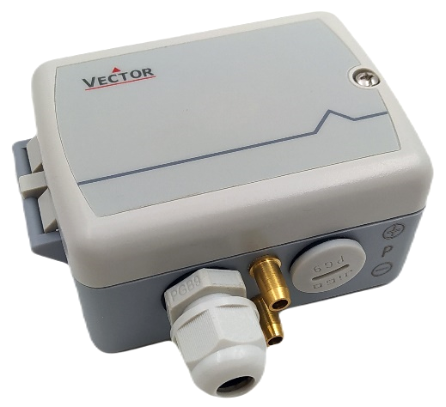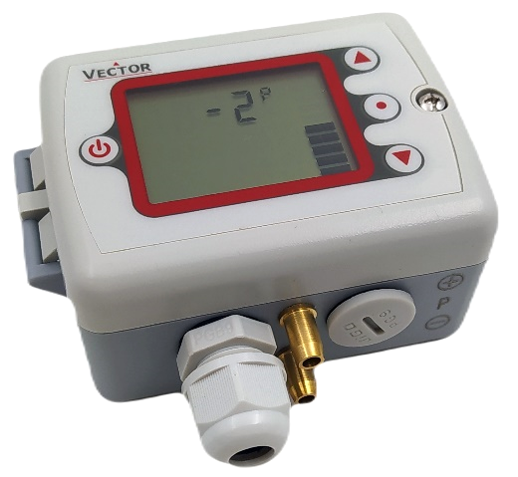

Programmable differential pressure transmitter SCC-P

with auto zero function
The SCC-P is a programmable differential pressure transmitter. The transmitter measures the differential pressure using a ceramic sensor. The signal is temperature compensated and calibrated. An auto zero function ensures that the transmitter has no zero offset. It is performed by default after power-up and periodically once a day. The pressure is measured every 100 ms, giving a sampling frequency of 10 Hz. The number of samples for the averaging filter and the minimum and maximum pressure can be configured with parameters. The transmitter calculates the output signal for the analogue output accordingly.

Features
- Measures air differential pressure
- Pressure measurement from ± 100 Pa up to ± 2500 Pa (± 10 mm to ± 250mm H2O, ± 0.4 to ± 10 in H2O)
- Integrated auto zeroing function using a solenoid valve
- DIP switch for pressure range pre-set
- Programmable pressure output signal range
- Selectable square root function
- Selectable averaging filter for the measurement signal
- Minimum and maximum pressure memory
- Set display range and value. This may be used to visualize air flow or air volume
- 0(2)…10 V / 0(4)…20 mA measuring signal output (range programmable)

Applications
- Pressure measurement in the field of heating, ventilation and air conditioning
- Measuring of air flow velocity
- Measuring and control of positive or negative pressure for example for clean rooms
- Measure exactly the pressure range you need
- Recording of minimum and maximum values for critical environments
- Supervision of critical pressures

Auto Zero
The Auto Zero function zeroes out any differential pressure that may be present in a system during normal operation. This allows the differential pressure in a system to be effectively measured.
- Auto Zero automatically calibrates the zero offset to 0 Pa.
- Auto Zero is performed on start-up.
- The auto-zero process may be repeated in an interval which is defined with IP09. The default setting for this interval is 24 hours. Setting IP09 to 0 will prevent automatic re-calibration.
- During the auto zero process, which takes approximately 5 seconds, the pressure reading and analogue output are frozen.

Pressure range configuration
The measuring pressure range of the selected SCC-P type can be set with DIP switches or fine-tuned with configuration parameters.

- Pressure range configuration with DIP switch
The following pre-set pressure ranges can be selected with the DIP switches:

Number  (DIP switch) | Pressure  Range  [Pa] | SCC-P Sensor Type
Number  (DIP switch) | Pressure  Range  [Pa] | SCC-P2 | SCC-P3 | SCC-P4
0 ¹⁾ | -100…100% ²⁾ | ± 100 Pa | ± 500 Pa | ± 2500 Pa
1 | 0…100% | 0…100 Pa | 0…500 Pa | 0…2500 Pa
2 | 0…40% | 0…40 Pa | 0…200 Pa | 0…1000 Pa
3 | -40…40% | ± 40 Pa | ± 200 Pa | ± 1000 Pa
4 | 0…50% | 0…50 Pa | 0…250 Pa | 0…1250 Pa
5 | -50…50% | ± 50 Pa | ± 250 Pa | ± 1250 Pa
6 | 0…60% | 0…60 Pa | 0…300 Pa | 0…1500 Pa
7 | -60…60% | ± 60 Pa | ± 300 Pa | ± 1500 Pa
1) Standard position of DIP switch
2) Pressure range according to configuration parameter IP 03 and IP 04 (standard range -100%...100%)

 | For your convenience, use the DIP switches to select a pre-set pressure range. For details see section  “Pressure range selection” on page 6.

- Pressure range fine tuning with configuration parameters
The pressure signal can be fine-tuned to suit your system. Define your signal by setting a minimum and maximum pressure limit. The output will only react when the pressure is above the lower limit. The output signal will span up to the upper limit. This allows the full resolution of the output signal to be used even if only a fraction of the pressure sensor's signal range is used. For example, a 0-300 Pa transmitter can be converted to a 0-100 Pa transmitter. (Note: this does not improve the sensor resolution, only the output signal resolution).
 | For details see section “Pressure range selection”, page 6 and “Configuration Parameters”, page 7.

Minimum and maximum values
Using the optional built-in operation terminal "OPC-S V2" or the external operation terminal "OPA-S", the user has the possibility to read out and reset the minimum and maximum values. The minimum and maximum values can be sent to the output using parameter OP 00. In this way the sensor can be used to monitor pressure in critical environments. The minimum and maximum values are stored in the EEPROM every minute. They are available even after a power failure.

Square root function
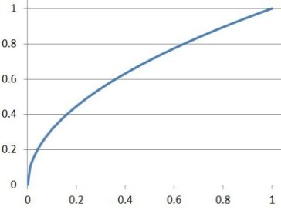
The input signal is multiplied by a square root function. This changes the signal curve to the typical square root shape. This is useful for direct measurement and control of air flows. The air flow is proportional to the square root of the differential pressure. The figure on the right shows the shape of the square root function.

Safety
 | DANGER! Safety advice  This device is intended for use as an operational controller or sensor. It is not a safety device. Where failure of the equipment could endanger life and property, it is the responsibility of the customer, installer and system designer to provide additional safety devices to prevent such failure. Failure to comply with specifications and local regulations may result in damage to the equipment and endanger life and property. Tampering with the unit and misuse will void the warranty.

Product Testing and Certification
 | Declaration of Conformity | Information on the conformity of our products can be found on our website www.vectorcontrols.com on the corresponding product page under "Downloads".

Types and Ordering
Product Name | Product No. | Description / Function
SCC-P2 | 40-300246 | Differential pressure sensor  Pressure range ± 100 Pa (± 10 mm, 0.4 in H2O)
SCC-P3 | 40-300247 | Differential pressure sensor  Pressure range ± 500 Pa (± 50 mm, 2 in H2O)
SCC-P4 | 40-300248 | Differential pressure sensor  Pressure range ±2.5 kPa (± 250 mm, 10 in H2O)

Accessories
Product Name | Product No. | Description
Built-in Operation Terminal
OPC-S | 40-500029 | Optional built-in operation terminal for SCC-P devices. Replaces housing cover
External Operation Terminal
OPA-S | 40-500006 | External operation terminal, for configuration only
OPU-S | 40-500030 | External operation terminal (US version), for configuration only
Probe
AMP-1 | 40-510087 | Differential pressure probes with 0.5m tube Ø 6mm

Documentation overview
Document Type | Document No. | Description
SCC-P Data Sheet | 70-00-1004 | Product data sheet (this document)
SCC-P Install Sheet | 70-00-0999 | Mounting and installation instructions
OPA-S Operation Manual | 70-00-0171 | Operations instructions for external operation terminal  OPA-S
OPU-S Short Instruction | 70-00-0303 | Short instructions for external operation terminal  OPU-S (US version)

Note: The above list is not complete. The documents on the website are relevant.

Technical specifications

Power supply | Power requirements | 24 VAC ±10% 50/60 Hz, 24 VDC ±10%
Power supply | Power consumption | Max. 2 VA
Power supply | Safety extra low voltage (SELV) | HD 384, Class II
Power supply | Electrical connection | Screw terminal for wire 0.32…2.0 mm² (AWG 22…14)
Signal inputs | Product type | SCC-P2 | SCC-P3 | SCC-P4
Signal inputs | Static sensor type: | Ceramic | Ceramic | Ceramic
Signal inputs | Auto-zero-function | yes | yes | yes
Signal inputs | Pressure range | ± 100 Pa  (± 0.4 in H₂O) | ± 500 Pa  (±2.0 in H₂O) | ± 2500 Pa  (± 10 in H₂O)
Signal inputs | Error band after zeroing | < 1 % FSS | < 2 %FSS | < 1 %FSS
Signal inputs | Proof pressure (overload pressure) | 7 kPa (1.0 psi) | 14 kPa (2 psi) | 14 kPa (2 psi)
Signal inputs | Burst pressure | 20 kPa (2.9 psi) | 70 kPa (10 psi) | 70 kPa (10 psi)
Signal outputs | Analog outputs  Output signal  Resolution  Maximum load | Analog output for differential pressure signal  0/2...10 VDC or 0/4...20 mA  9.76 mV or 0.019 mA (10 bit)  Voltage: ≥1kΩ Current: ≤500Ω
Environment | Operation  Climatic conditions  Temperature  Humidity | To IEC 721-3-3  class 3K5  0…50 °C (32…122 °F)  <85 % RH non-condensing
 | Transport & storage  Climatic conditions  Temperature  Humidity  Mechanical conditions | To IEC 721-3-2 and IEC 721-3-1  class 3K3 and class 1K3  0…50 °C (32…122 °F)  <95 % RH non-condensing  class 2M2
Standards | Degree of protection | IP65 to EN 60 529
Standards | Pollution class | II (EN 60 730-1)
Standards | Safety class: | III (IEC 60536)
Standards | Overvoltage category | II (EN 60 730-1)
General | Material | Flame retardant PC+ABS plastic (UL94 class V-0)
General | Dimensions (H x W x D) | 47 x 98 x 90 mm (1.9 x 3.9 x 3.5 in)
General | Weight (including package)  with standard housing cover  with OPC-S V2 operation terminal | 192 g (6.8 oz)  239g (8.4 oz)

Dimensions, mm (inch)

Mounting and Installation

Mounting instructions
For details see "SCC-P" install sheet, document no. 70-00-0999 on our webpage www.vectorcontrols.com

Connection diagram

1 | +V | Power supply: | 24 VAC 50-60 Hz, +24 VDC, ±10%
2 | GND | Power supply: | 0 V, -24 VDC, internally connected to signal common
3 | AO1 | Analog output: | DC 0(2)…10 V  DC 0(4)…20 mA

Jumper settings
Analog output AO1

Pressure range selection
The pressure range of the selected SCC-P type can be further adjusted according to the following table and by setting the DIP switches accordingly.

For other pressure ranges, set the DIP switch number to 0 and adjust the configuration parameter IP 03 and IP 04 accordingly.
For details see section “Configuration Parameters”, page 7.

Number  (DIP switch) | Pressure  Range  [Pa] | SCC-P Sensor Type
Number  (DIP switch) | Pressure  Range  [Pa] | SCC-P2 | SCC-P3 | SCC-P4
0 ¹⁾ | -100…100% ²⁾ | ± 100 Pa | ± 500 Pa | ± 2500 Pa
1 | 0…100% | 0…100 Pa | 0…500 Pa | 0…2500 Pa
2 | 0…40% | 0…40 Pa | 0…200 Pa | 0…1000 Pa
3 | -40…40% | ± 40 Pa | ± 200 Pa | ± 1000 Pa
4 | 0…50% | 0…50 Pa | 0…250 Pa | 0…1250 Pa
5 | -50…50% | ± 50 Pa | ± 250 Pa | ± 1250 Pa
6 | 0…60% | 0…60 Pa | 0…300 Pa | 0…1500 Pa
7 | -60…60% | ± 60 Pa | ± 300 Pa | ± 1500 Pa
1) Standard position of DIP switch
2) Pressure range according to configuration parameter IP 03 and IP 04 (standard range -100%...100%)

DIP switch positions
Figure 1: All DIP switches in position OFF
Figure 2: All DIP switches in position ON
Number | Position  DIP switch  1 | Position  DIP switch  2 | Position  DIP switch  3
0 ¹⁾ = | OFF | OFF | OFF
1 = | ON | OFF | OFF
2 = | OFF | ON | OFF
3 = | ON | ON | OFF
4 = | OFF | OFF | ON
5 = | ON | OFF | ON
6 = | OFF | ON | ON
7 = | ON | ON | ON
1) Standard position

LED-indicator
A status LED is located inside of the transmitter housing.
During normal operation the LED blinks briefly once every 5 seconds.
If there is an alarm or fault condition it will light up steady.
During power up and if a setting is saved, it will light up for 3 seconds.

For details see OPA-S operation manual, document no. 70-00-0171 or OPU-S short instruction, document no.
70-00-0303.

Configuration Parameters
The transmitter can be perfectly adapted to the application. Its parameters are set using the built-in operation terminal OPC-S V2 or the external operation terminals OPA-S / OPU-S. In order to use all the functions described below and to obtain a correct display, only OPA-S or OPU-S units with firmware version V1.5 or higher should be used.

Pressure input configuration
Parameter | Description | Range | Standard
IP 00 | Display of pressure signal:  OFF = no unit, range is defined with IP06 and IP07,  ON = range is fixed to -100 to 100% | ON/OFF | ON (%)
IP 01 | Samples taken for averaging control signal. The SCC-P is a fast sensor. It measures every 0.1 seconds and applies a low pass filter that is controlled through this parameter. A setting of 20 equals an averaging time of about 3 seconds. | 1…255 | 5
IP 02 | Calibration | -10…10% | 0
IP 03 | Minimum pressure range:  Pressure when output is at its minimum  Note: This parameter is overwritten by the DIP-Switch.  Customized settings must be done with DIP Switch position = 0 | -100…100% | -100…100%
IP 04 | Maximum pressure range:  Pressure when output is at its maximum  Note: This parameter is overwritten by the DIP-Switch.  Customized settings must be done with DIP Switch position = 0 | -100…100% | -100…100%
IP 05 | Square root measurement functions  OFF = linear measurement  ON = the input signal is processed with a square root function | ON/OFF | OFF
IP 06* | Display value range. Converts the display range when IP00 is OFF.  Value shown on the display unit when output is 100%. Can be used to visualize air pressure in Pa or inch H²O, air flow or air volume based on differential pressure. | 0...255 | 100
IP 07* | Display value scale  0 = x 0.01 (only for OPU-S and OPC-S V2)  1 = x 0.1 (only for OPU-S and OPC-S V2)  2 = x 1  3 = x 10  4 = x 100 | 0...4 | 2
IP 08 | Scaling factor. The measured value will be divided by this factor.  Keep at 100% for standard applications. | 0…100% | 100%
IP 09 | Auto zero interval: After each interval, the device will calibrate  Setting this value to 0, prevents automatic zero calibration. | 0…255 h | 24 h
See chapter “Display value as pressure (Pa, inches H²O) instead of percentage value (%)”

Analog output configuration
Parameter | Description | Range | Standard
OP 00 | Configuration output signal:  0 = Feedback pressure input  1 = Feedback pressure minimum value  2 = Feedback pressure maximum value | 0…2 | 0
OP 01 | Minimum limitation of output signal. | 0…Max. % | 0%
OP 02 | Maximum limitation of output signal | Min.…100% | 100%

Display value as pressure (Pa, inches H²O) instead of percentage value (%)
When IP 00 = OFF, the following parameter combinations can be used to convert from percentage display to pressure display in Pa or inches H2O. These parameters do not affect the analog output value.

Parameter | SCC-P2 |  | SCC-P3 |  | SCC-P4
Parameter | -100 … 100  Pa | -0.40 … 0.40  inch H²O | -500 … 500  Pa | -2.00 … 2.00  inch H²O | -2500 … 2500  Pa | -10.0 … 10.0  inch H²O
IP 00 | OFF | OFF | OFF | OFF | OFF | OFF
IP 06 | 100 | 40 | 50 | 200 | 250 | 100
IP 07 | 2 | 0 | 3 | 0 | 3 | 1
Interpretation | 100*1  = 100 Pa | 40*0.01  = 0.4 inH²O | 50*10  = 500 Pa | 200*0.01  = 2 inH²O | 250*10  = 2500 Pa | 100*0.1  = 10 inH²O

Calculation of displayed pressure value: $Value [\%] * IP06 * IP07$

Pa to inch H²O conversion: $\frac{xxx Pa}{250} = xxx in H2O$

Empty page.

Smart Sensors and Controls
Made Easy!
Quality - Innovation – Partnership
Vector Controls LLC
USA

infous@vectorcontrols.com
www.vectorcontrols.com



